A WOMAN HUSBAND SURNAME MADE HER LOSE A JOB, CHECK OUT WHY
ladies, thats why u have to check the name of your husband, before you marry. A woman lost a job, after the outsourcing company called her for confirmation of her name, and it sounded rude over the phone
we hope she gets another job though
the name sha funny
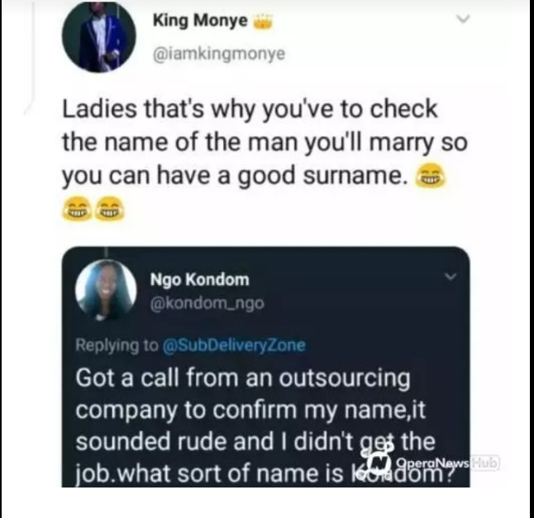

personally i believe this is wrong and prejudicial
lets know what u think about this in the comment box below
CODE - BurkinaFaso11

